Tittle of the conference is placed here.

.

Name Surname^{1*}, Name Surname ¹, Name Surname ²
¹ Affiliation
² Affiliation
*email corresponding author
Keywords: keyword1, keyword2, keyword3.

ABSTRACT
The two-page abstract submission deadline is July 25th. Here is the body of the abstract. Please summarize the motivations of the contribution, the methodology used, the main results achieved (including important equations and representative figures to highlight the main achievement). Please do not include page numbers, since these will be assigned later in the conference proceedings document. Please submit the Word file following the submission instructions to be posted in the website. The Word file should have a unique name, e.g. “Abstract ICMET2024 [name of first author].xlsx”.
Example of figure reference Figure 1.

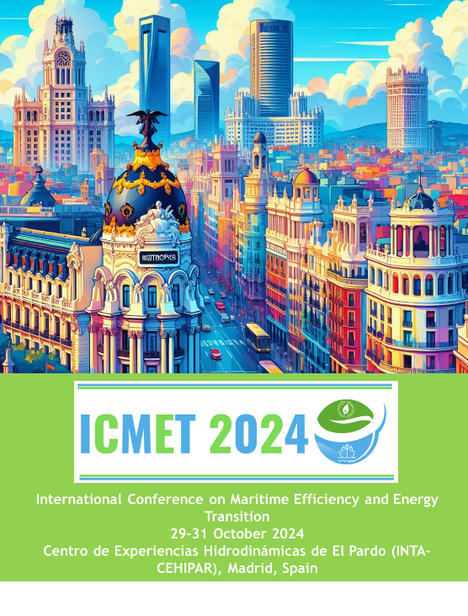
Figure 1: Example of figure.

Example of equation:
$$\frac{∂\left(ρe\right)}{∂t}+∇⋅\left(\left(ρe+p\right)u\right)=∇⋅\left(τ⋅u\right)+ρfu+∇⋅\left(\dot{q}\right)+r$$

Here are four examples of citations for journal article with one or more authors, book, and conference proceeding: Jiménez (2004), Castellanos et al. (2022), Gad-el Hak (2000), Güemes et al. (2019).
Example of table:
Column 1 | Column 2 | Column 3
X1 | Y1 | Z1
X2 | Y2 | Z2
Table 1: Example of table.

Acknowledgements
This investigation has been funded by Funder Name.

References
Castellanos, R., Michelis, T., Discetti, S., Ianiro, A., & Kotsonis, M. (2022). Reducing turbulent convective heat transfer with streamwise plasma vortex generators. Experimental Thermal and Fluid Science, 134, 110596.
Gad-el-Hak, M. (2000). Flow Control: Passive, Active, and Reactive Flow Management. Cambridge: Cambridge University Press. doi:10.1017/CBO9780511529535.
Güemes, A., Ianiro, A., & Discetti, S. (2019). Experimental assessment of large-scale motions in turbulent boundary layers. In 13th International Symposium on Particle Image Velocimetry. July 22-24, 2019, Munich, Germany.
Jiménez, J. (2004). Turbulent flows over rough walls. Annu. Rev. Fluid Mech., 36, 173-196.

